
Kind Attention – Mr. Arvind Seshadri
FALCON’s Response to RFP
Flipkart for Supply of SWEDI + ARM Sorter System
June 2, 2023
Mr. Hemanth Kumar
Mr. Sandesh Mulik
Mr. Palvannan K

M/s Flipkart Private Limited

Location – Anjaneya

Offer Ref: F23_00127; Date 02.06.2023

Subject – Techno-Commercial Offer for SWEDI+ARM Sorter

Dear Team,

We are pleased to submit our Techno-Commercial Offer in response to your RFP
As you will note, we have studied your requirements in great depth and, along with the information collected during the workshops and calls with you, we have put together a detailed technical proposal laid out in various sections and sequenced to enable you to understand our proposed solution and to re-enforce our commitment to be your partner in this strategic initiative.
In subsequent sections, we have highlighted the capabilities and experiences of Falcon Autotech with sections on our Automation Technologies and references.
To conclude, I would like to add my personal commitment, on behalf of Falcon Autotech. As we move through the RFP process, please do not hesitate to contact me and my team. We will be pleased to assist you for any further information or clarifications that you might have.
tails
Contact Person : Sanyog Pratap Singh
Title : Assistant Manager
Mobile : +91-8750052591
Email : Sanyog.singh@falconautoonline.com
Company Details
Company Name : Falcon Autotech Pvt. Ltd.
Regd. Office : 57, Nimri Colony, Double Storey Flats, Delhi – 110052
Website : www.falconautotech.com

Response to RFP for SWEDI+ARM Sorter_ 1500 PPH

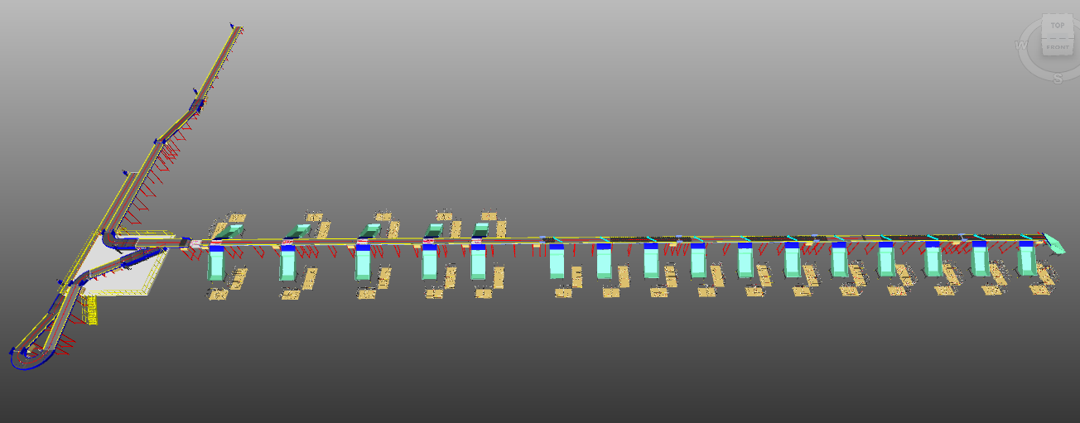

Proposal Reference – F23-00127

Falcon Autotech Private Limited
Plot No 308 & 309
Ecotech-1 Extension, Greater Noida
Uttar Pradesh- 201308
India.

Sanyog Pratap Singh
Asst. Manager
+91-8750052591
sanyog.singh@falconautoonine.com

Table of Contents
1. Glossary 6
2. About Falcon 7
3. Falcon’s Experience and Achievements in Sortation Space Globally 19
4. Reference projects 20
4.1 Project 1- (Client – Courier Express Parcel, Dubai & Jeddah) 20
4.2 Project 2- (Client – E-Commerce, India) 21
4.3 Project 3- (CEP Client, Riyadh) 22
4.4 Project 4- (CEP Client, UK) 23
4.5 Project 5- (CEP Client, Sydney) 24
4.6 Project 6- (Ecommerce Client, India) 25
4.7 Project 7- (E-commerce, India) 26
5. Handled Parcel Spectrumins Minimum Maximum 27
5.1 Product size Conveyable on the entire system. 27
5.2 Parcels/Totes to be loaded on Conveyor/Sorter shall have the following characteristics: 27
5.3 Parcel not loadable on the system 28
5.4 Types of Products 28
6. Proposed System Description 29
6.1 Objective 29
6.2 Summary of the System 29
6.3 Main benefits of the proposed solution 29
7. Layout View 30
8. Proposed System Capacity 31
8.1 System Capacity 31
9. System description 31
9.1 Loading conveyor 31
9.2 Manual Scanning 32
9.3 Parcel Induction 32
9.4 Outbound Sorting 33
10. System Components 34
10.1 PVC Belt Conveyor 34
10.2 Plastic Modular Belt Conveyor 36
10.3 Swivel Wheel Sorting Unit - Falcon 37
10.4 ARM Sorting Unit 37
10.5 Powered Belt Merges & ZTR Curves (Pic for ref.) 38
10.6 Handheld Barcode Scanners 38
10.7 Collection Type Chute 39
10.8 Operator’s Platform 39
10.9 Stair case 40
11. Proposed System Technical Details/BOM 40
11.1 Mechanical Equipment 40
11.2 Electrical Equipment 41
11.3 Control System 41
12. Falcon’s WCS CONTROLIT 42
13. High Availability Server Specifications (In Flipkart’s Scope) 43
14. Key Component Makes 44
15. Safety 45
15.1 Push Buttons 45
15.2 Program Management 45
16. Commercial Terms 46
16.1 Price Sheet 46
16.2 Payment Terms 46
16.3 Delivery timeline 47
17. Warranty Period 47
18. Exclusions 48

Glossary
S. No. | Term | Description
1 | RFP | Request For Proposal
2 | PPH | Parcels Per Hour
3 | DBO | Damaged Barcode
4 | MEZZ | Mezzanine
5 | AC | Alternating Current
6 | DC | Direct Current
7 | PLC | Programmable Logic Controller
8 | IT | Information Technology
9 | BOQ | Bill Of Quantity
10 | I/O | Input/ Output
11 | PDP | Power Distribution Panel
12 | PC | Personal Computer
13 | UPS | Uninterrupted Power Supply
14 | SWEDI | Swivel Wheel Divert

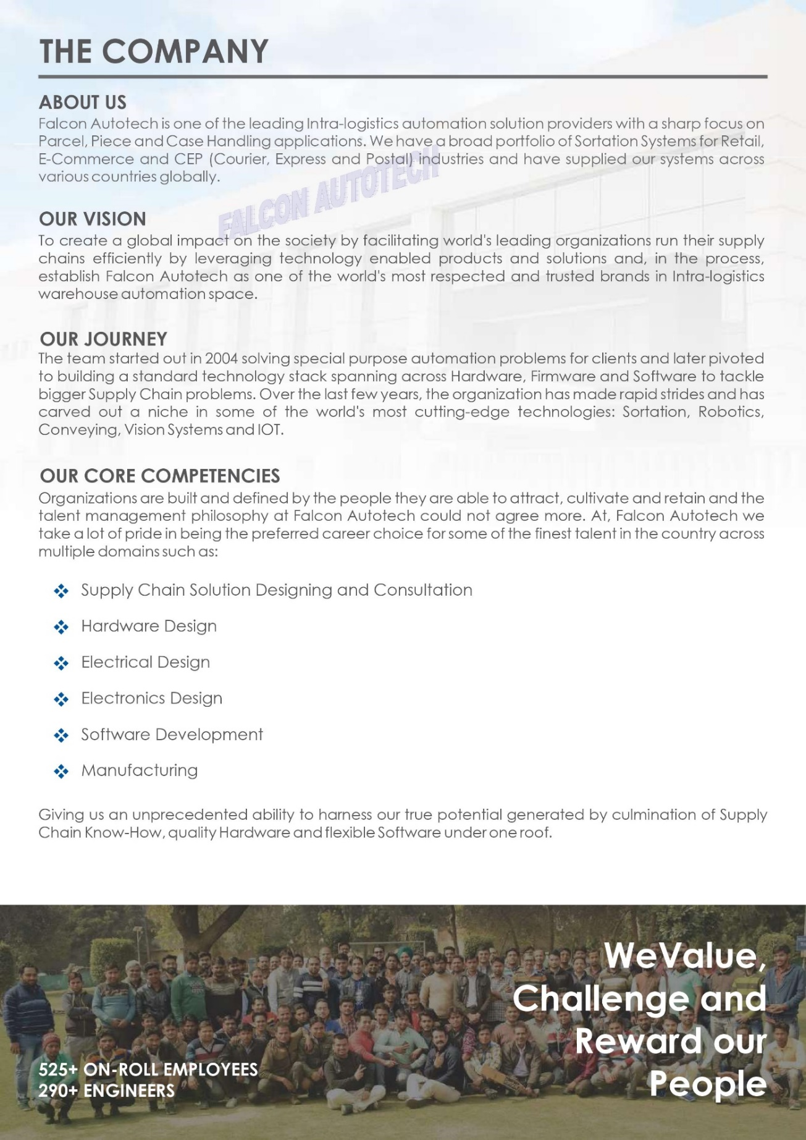
About Falcon
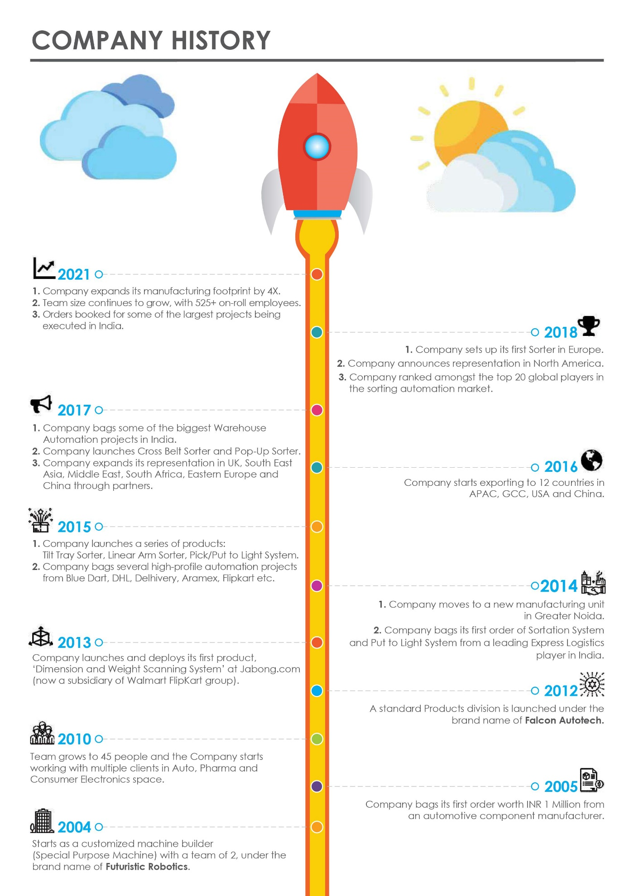
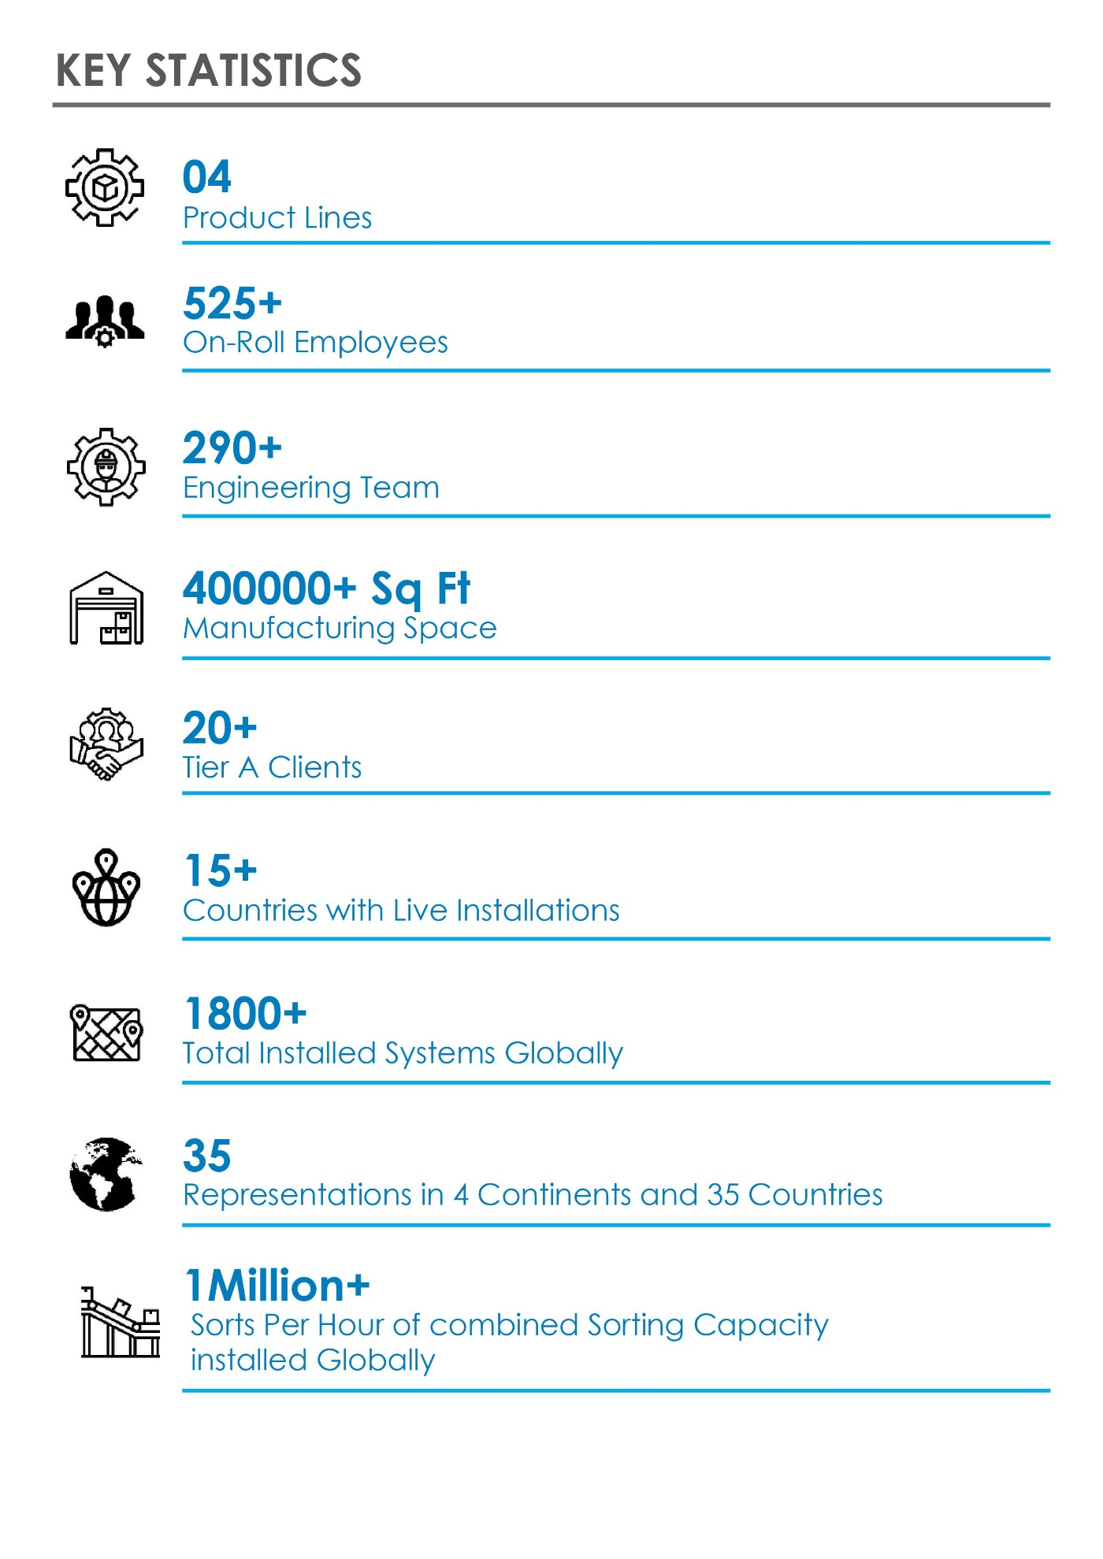
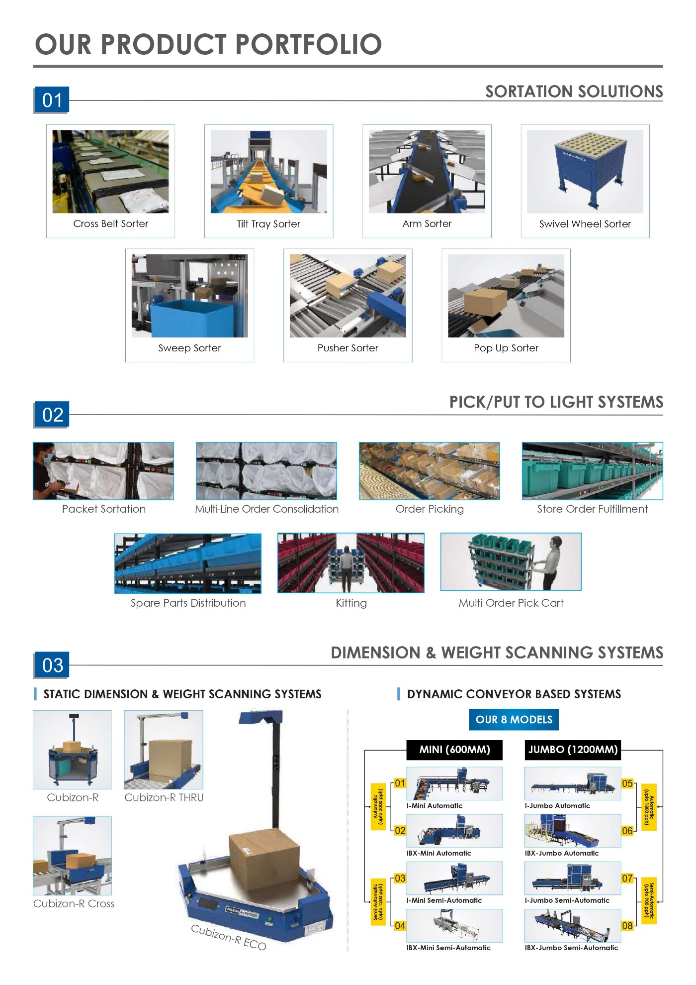
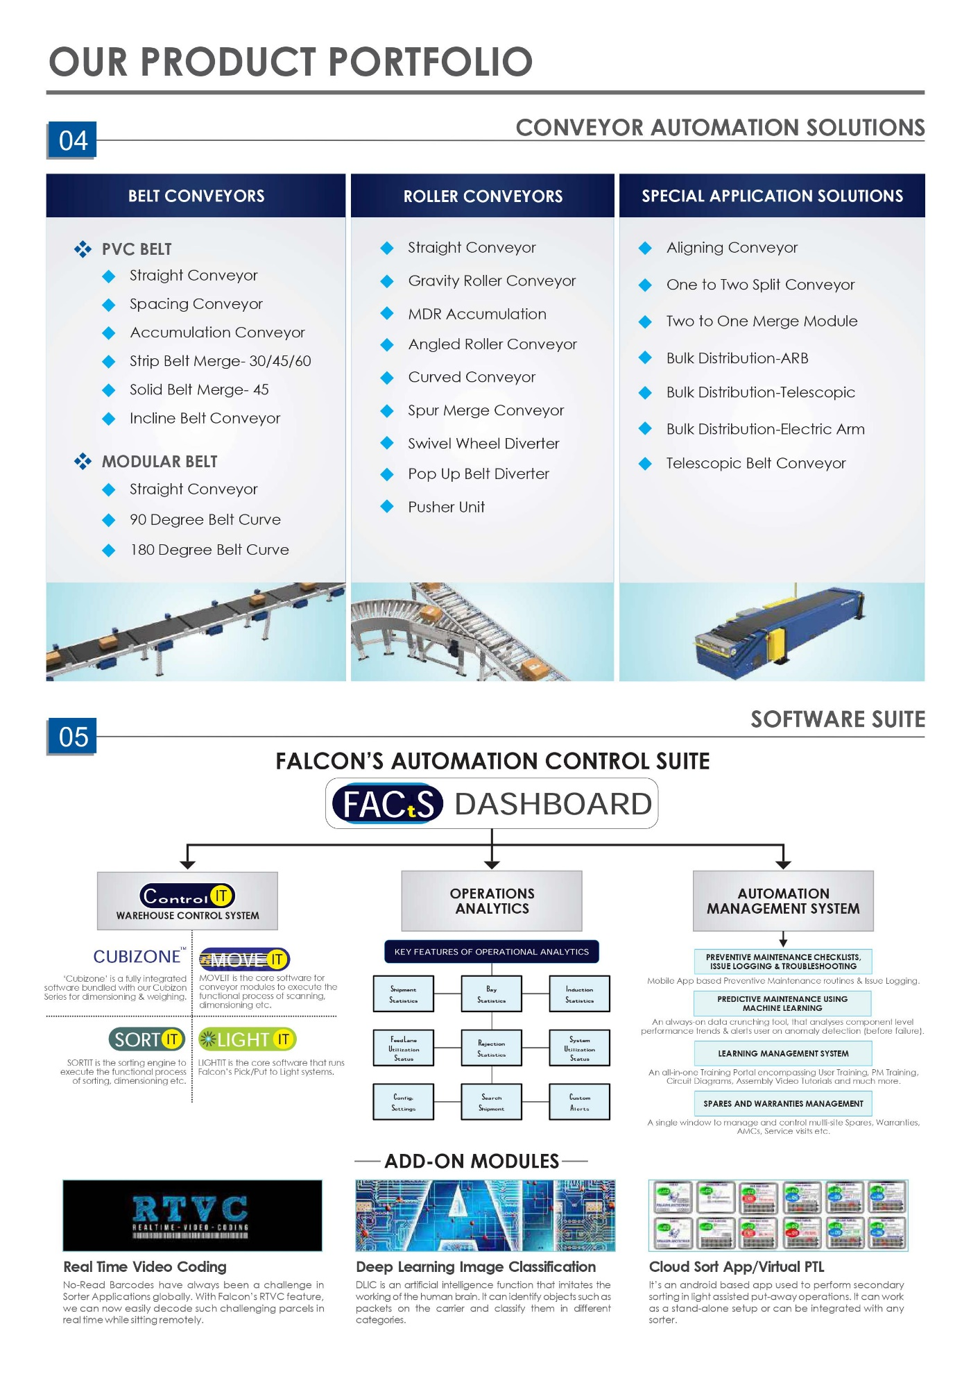
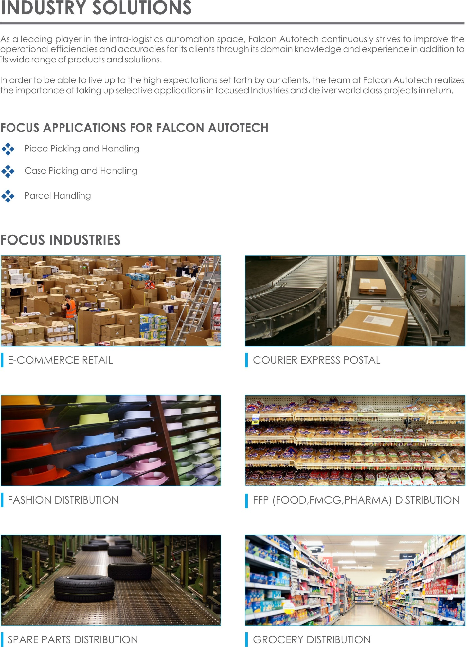
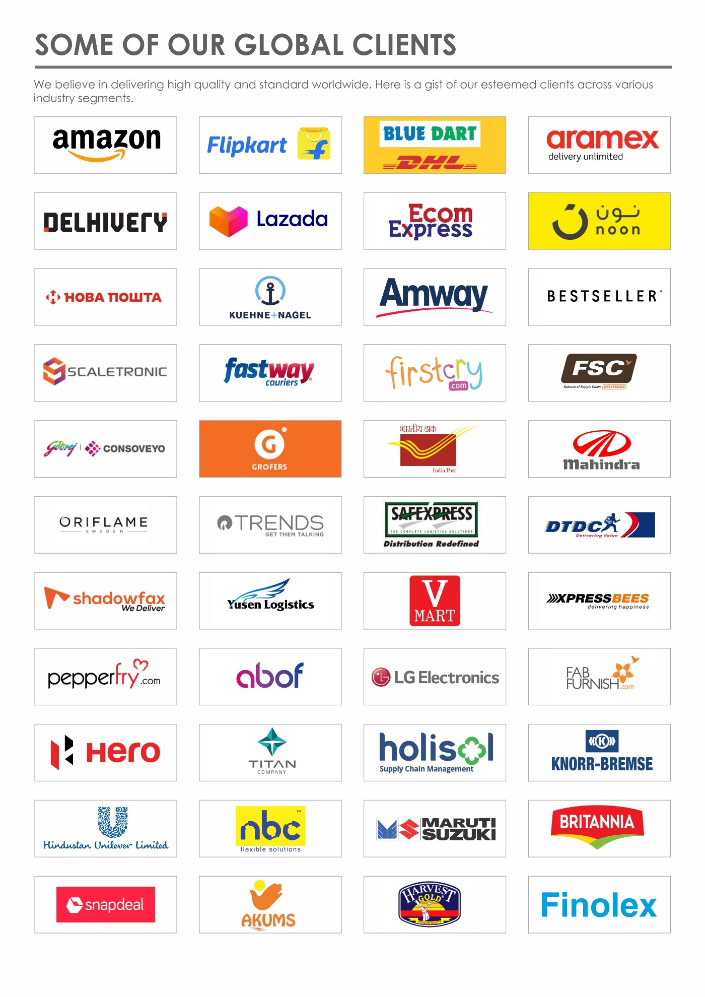



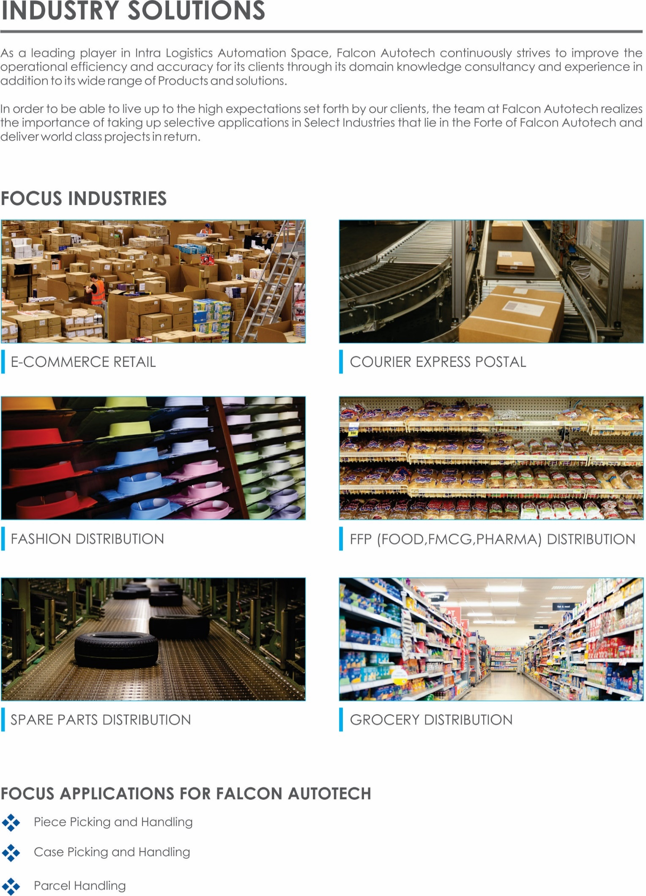

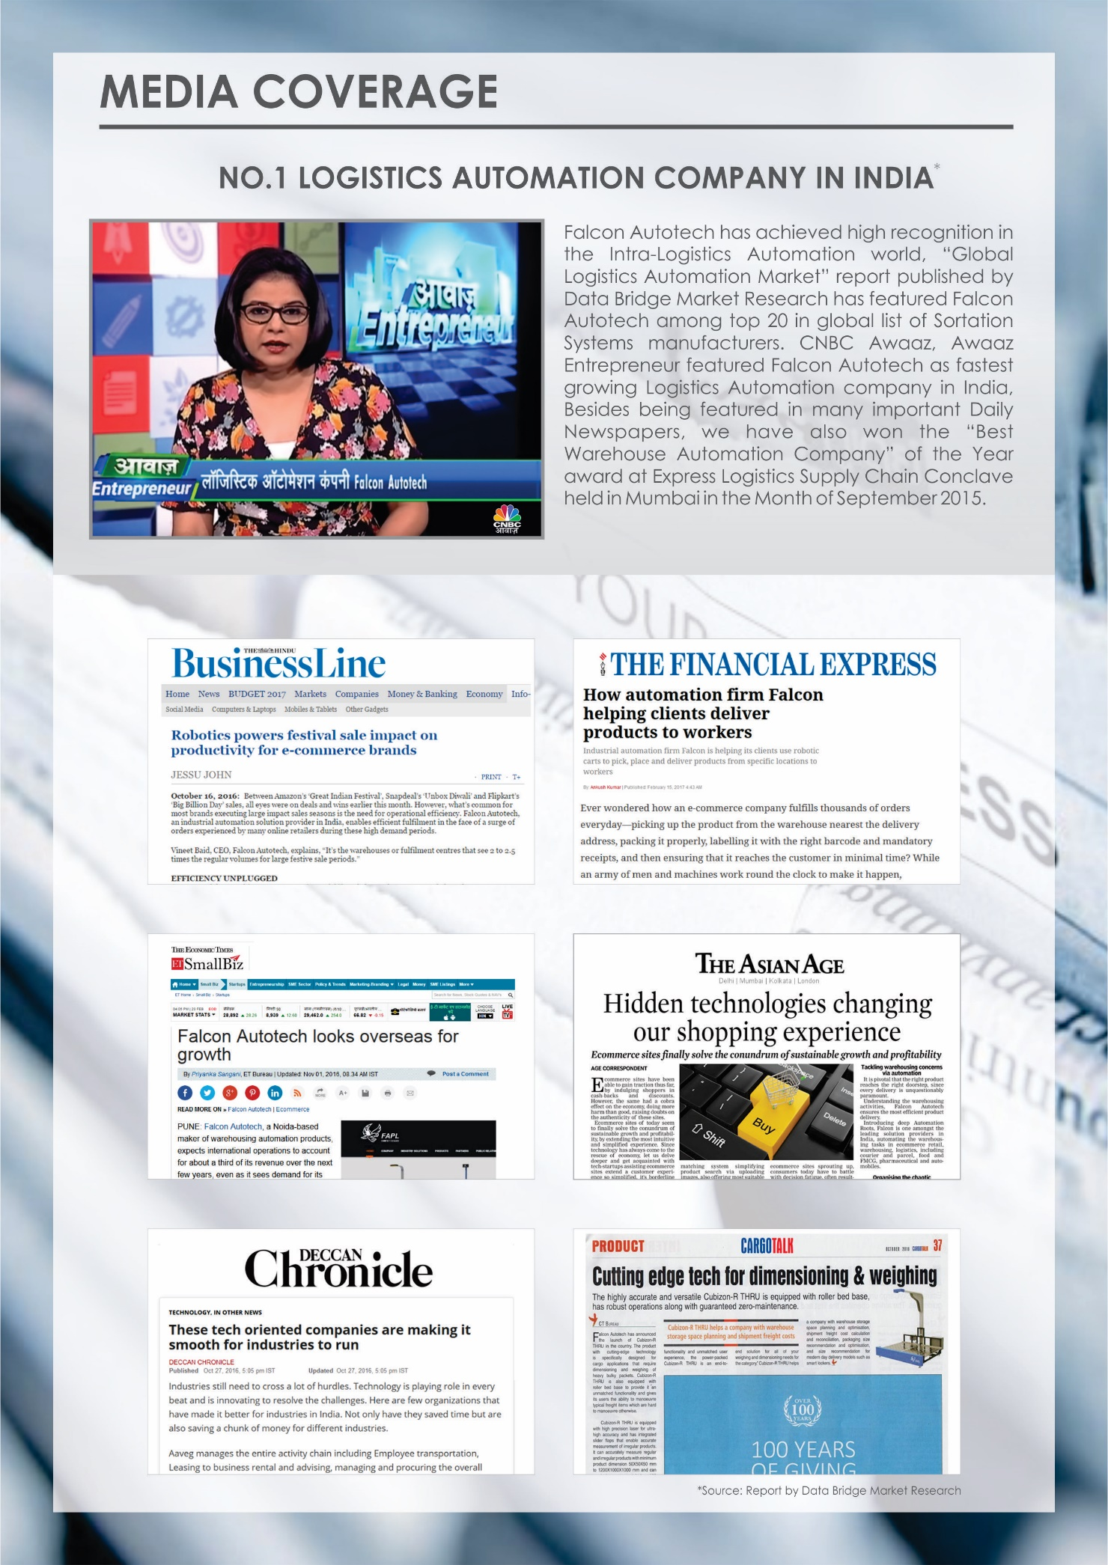



Falcon’s Experience and Achievements in Sortation Space Globally
- Ranked among Top 20 Sortation System Suppliers globally. Only company from APAC/EMEA Region.
- Currently possess one of the World’s largest portfolio in Sortation Technologies: 7 In-house technologies.
- Total installed capacity of 6 Million Parcels per day worldwide.
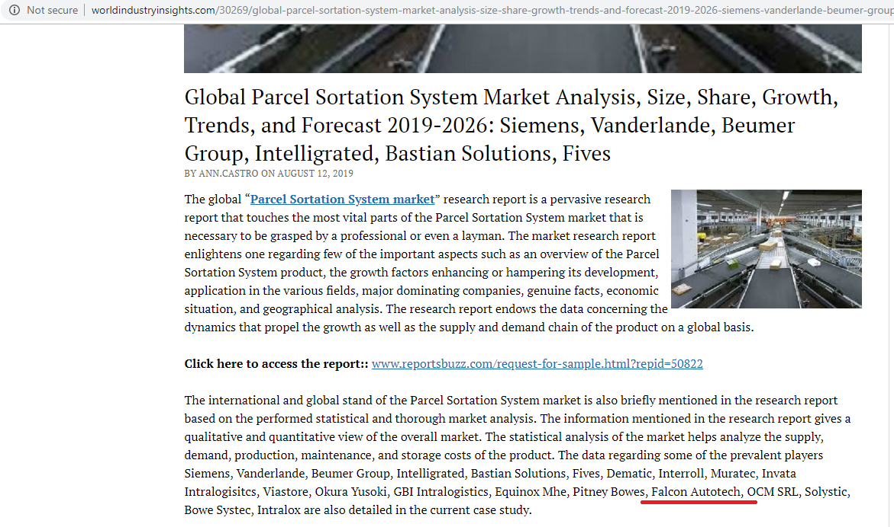
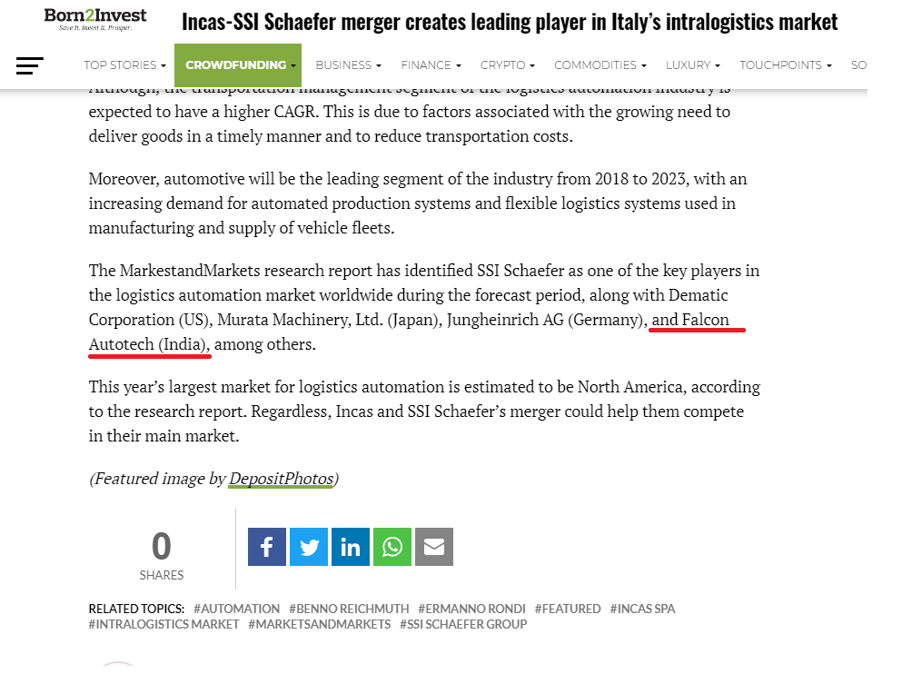
- Only company to be able to offer a Fully Integrated AMS.

Reference projects
Falcon has a strong legacy in Warehousing Automation solutions and references-

- Expertise in Piece Picking and Handling, Case Picking and Handling & Parcel Handling
- Lifecycle services (maintenance, spares supply chain, support).
- Full in-house expertise (Hardware/Software).
- Turn-key tailored solutions.
The references list presented below focusing on Sortation Solution –

Project 1- (Client – Courier Express Parcel, Dubai & Jeddah)
This Solution is designed to handle the bulk volumes through Launchpads and induct them into Falcon's Linear Arm Sorter. This system is designed for a throughput of 3000 parcels per hour equipped with automatic barcode scanning, dimensioning, weighing and image capture capabilities to into a total of 480 end destinations with a combination of primary and secondary sortation system. The secondary sortation is achieved by integrating put to light system.
Solution Specifications –
- Throughput: 3000 PPH
- End Destinations: 480 Nos
Key Technology Modules –
- Powered Belt Conveyors.
- Linear arm sorter.
- Automatic Barcode Scanner.
- Automatic Weight & Volume Measurement System.
- WCS Software System.
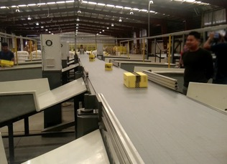
Site Picture –

Project 2- (Client – E-Commerce, India)
Use Case – Destination Sorting of Packed Parcels.
In 2019, Client was looking for a potential automation partner for design and development of a new automated sortation system for B2C parcels. The system should be able to provide maximum uptime with reduced dependency on skilled manpower, and space optimization.
The customer chose Falcon Autotech based on its unique design which could cater to all their pain points, capability of seamless integration with WMS and life cycle support services.
Solution Specifications –
- Throughput: 27,600 PPH
- End Destinations: 410 Direct Outputs
- Building Size: 200,000 Sq Ft
Key Technology Modules –
- Bulk Infeed Conveyors.
- ARB based Volume Distribution System
- Integrated Presort System.
- Irregular Ejection System.
- Automatic Induct Lines.
- Automatic Barcode Scanner with Image Capture.
- Automatic Weight & Volume Measurement System.
- Loop Cross Belt Sorter.
- Smart Sliding Chutes for Direct bagging and Cage Sorting.
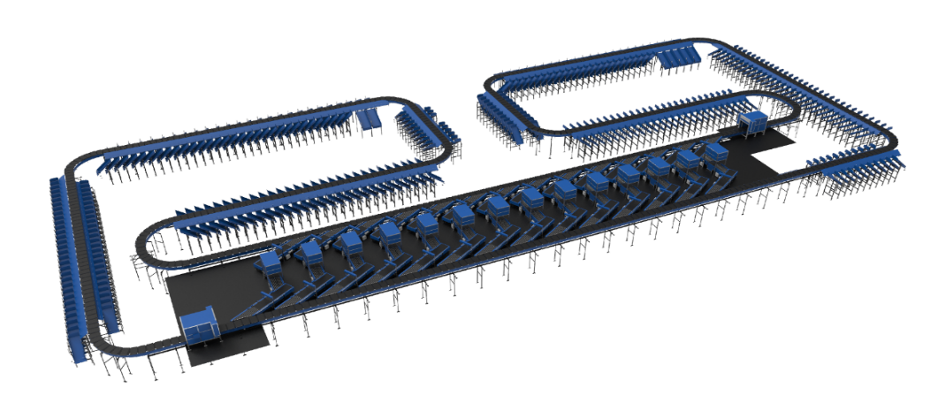
- Bag take out system
- WCS Software System.

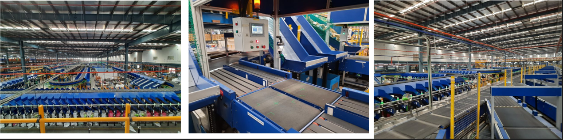

Project 3- (CEP Client, Riyadh)
In 2019, customer selected Falcon Autotech as a preferred supplier for its airport hub to supply linear cross belt sorter for processing of parcels arriving via Air from different states and countries to distribute them locally. The customer chose Falcon Autotech based on its strong track record of success in providing intralogistics automation solutions, optimized design, software integration capabilities and life cycle support services.
Solution Specifications –
- Throughput: 4800 PPH
- End Destinations: 52 Nos
Key Technology Modules –
- Powered Belt Conveyors.
- Automatic Induct Lines.
- Automatic Barcode Scanner with Image Capture.
- Automatic Weight & Volume Measurement System.
- ARB Conveyor.
- Automatic Label Applicators.
- Linear Cross Belt Sorter.
- Specialized Chutes for Gentle Parcel handling.
- FOCR Engine.
- WCS Software System.
Site Picture –
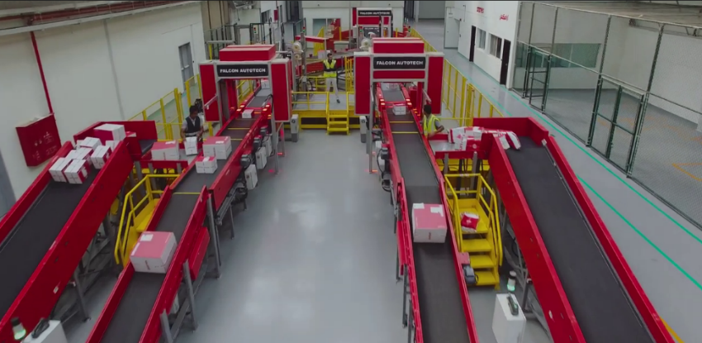

Project 4- (CEP Client, UK)
This Solution is designed to handle a volume of 7200 parcels per hour. The system is equipped with three infeed conveyors integrated with automatic label applicator before parcels enter the sortation system. The parcels are sorted using Falcon's Loop Cross Belt Sorter equipped with automatic barcode scanning, dimensioning, weighing and image capture capabilities. The sorter is installed on the mezzanine floor and sorts directly to 58 end destinations.
Solution Specifications –
- Throughput: 7200 PPH
- End Destinations: 58 Nos
Key Technology Modules –
- Powered Belt Conveyors.
- Automatic Induct Lines.
- Automatic Barcode Scanner with Image Capture.
- Automatic Weight & Volume Measurement System.
- Loop Cross Belt Sorter.
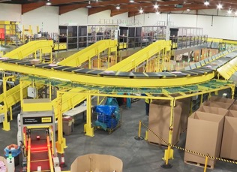
- WCS Software System.
Site Picture –

Project 5- (CEP Client, Sydney)
Solution is designed for handling a throughput of 16,000 parcels per hour with the help of Falcon’s Loop Cross Belt Sorter. The system consists of 2 feeding zones with a total of 10 feedlines. Sorter design enables the van drivers to directly drop the parcels at the dock doors. It has a total of 369 end destinations that are achieved with a combination of direct drops and PTLs. System is integrated with 5 side automatic barcode scanning, weight and volume measurement and automatic detection of oversize and overweight parcels.
Solution Specifications –
- Throughput: 16000 PPH
- End Destinations: 369 Nos
Key Technology Modules –
- Powered Belt Conveyors.
- 2 Induct zone.
- 5 side Automatic Barcode Scanner.
- Automatic Weight & Volume Measurement System.
- Automatic detection of oversize parcel.
- Loop Cross Belt Sorter.
- WCS Software System.
Site Picture –
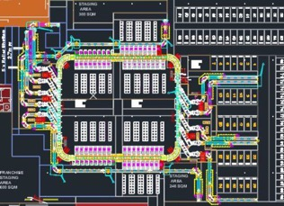

Project 6- (Ecommerce Client, India)
Use Case - Destination Sorting of Packed Shipments
Solution Specifications –
- Throughput: 24,000 PPH
- End Destinations: 110
- Building Size: 200,000 Sq. Ft
Key Technology Modules - Loop Cross Belt Sorter with a cell size of 900 x 500 mm

Layout and Site Pictures -

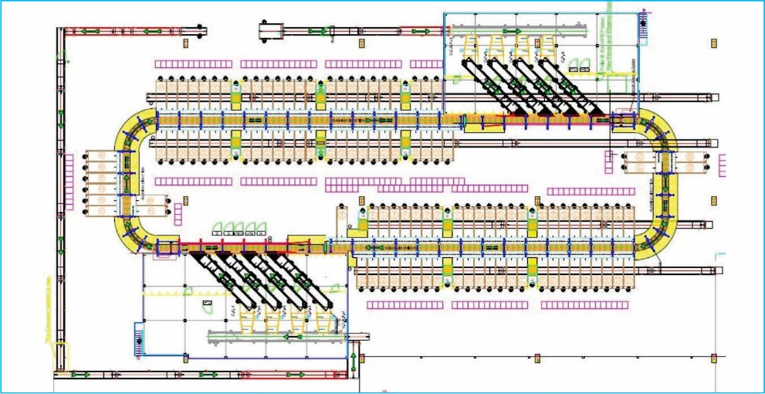

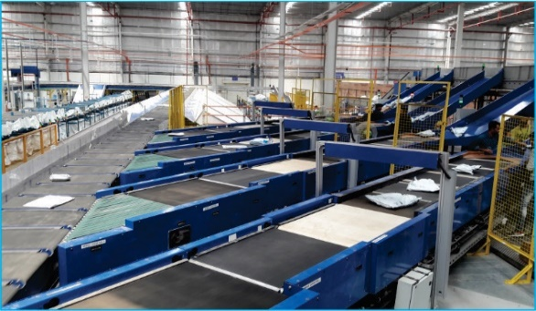
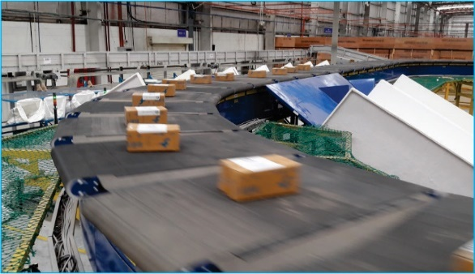
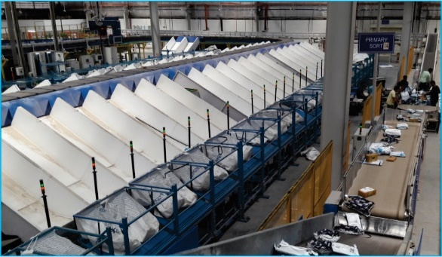

Layout & Pictures_ Project 1

Project 7- (E-commerce, India)
Solution is designed to handle the parcels Inbound and Outbound for packaging and sorting. Types of conveyors have used in this solution are as follows :
- Belt Conveyor
- Roller Conveyor
- Goose Neck Inclined

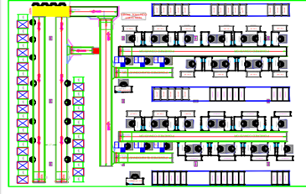

Handled Parcel Spectrumins Minimum Maximum

Product size Conveyable on the entire system.

Max Length | mm | 1200
Max Width | mm | 600
Max Height | mm | 600
Max Weight | Kg | 35
Min Length | mm | 150
Min Width | mm | 150
Min Height | mm | 10
Max Weight | Kg | 2

Parcels/Totes to be loaded on Conveyor/Sorter shall have the following characteristics:

- Centre of Gravity of items must not move during conveyance or sorting.
- Item must not have magnetic content; otherwise behaviour of parcel cannot be guaranteed.
- Liquid or fragile material, to avoid breaking, spillage or leakage, such as wine bottles, metal cans of paint are designated as non- conveyable items.
- Parcels shall be perfectly and safely packaged: protrusion or open surfaces are not allowed.
- Plastic ropes shall be perfectly adherent to the surface of the package.
- All items with the risk of being damaged during the transport on an automatic conveying/sorting system or damaging the system. They must be robust enough to avoid disintegration of container material and loose of contents in the conveying/sorting process.
- Item packaging shall have enough grip to be handled on the belts during the acceleration and
referencing phases.
- Items shall not have slippery surfaces and must be able to withstand acceleration of the items on the belt during the start-stop phases (accelerations up to 0.5 g shall be assured without any sliding or tumbling of the items on the belt conveyor).
- The parcels must have at least one flat and regular surface providing enough stability during conveyance.
- All shapes are permitted except spherical, cylindrical, or alike unstable items & shapes.
- All usual packaging materials are permitted (including paper, carton, plastics, plastic foil, rope, tape, textile, and wood)

Parcel not loadable on the system
All products that are not within the range as described here, are considered non- conveyable products, and must be taken out of the main sorter flow by the operators.

- Unstable items with a risk to roll or tumble on the sorting system, such as spherical or cylindrical items
- Items that have a spherical or cylindrical shape.
- Items that are packed in material that can damage the conveyors or the sorter.
- Items that have sharp points (e.g. Nails) or sharp edges, that can damage the conveyors or the sorter.
- Fragile parcels with contents not sufficiently secured
- Items that have been classified as dangerous are designated.
- Wet items are designated.
- Items with anti-slip treatment.
- Items with protruding parts.
- Items with sharp edges.
- Inadequately packed items that could be damaged during automatic transportation.
- Electrostatically loaded items.
- Loose parts on loads and load carriers, such as adhesive tape, stickers, slips of paper, straps, wrap foil etc. are designated as non- conveyable items.

Types of Products
Parcel Type | Description
Bags/Semi Large Shipment | Max: L 1200 mm X W 600 mm X H 600 mm  Min: L 150 mm X W 150 mm X H 10 mm

Proposed System Description

Objective
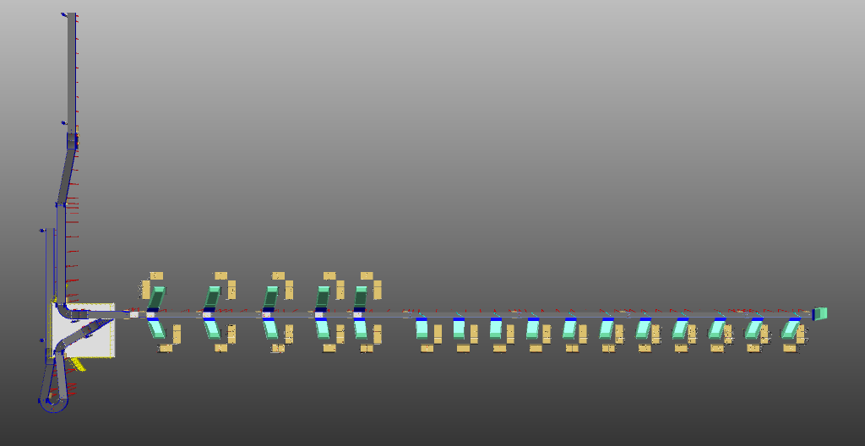
The purpose of this proposal is to present the design, manufacturing, installation, commissioning, testing and acceptance testing of the complete combination of SWEDI & ARM sorter system to handle Parcel as per specifications shared by Flipkart.

Summary of the System
- Infeed: Manual loading of Bags & Semi-large shipment is done by Operators on both loading conveyor.

- Parcel Scanning: Bags & Semi-large shipment are manually scanned with the help of hand-held scanner & then inducted through Semi-Automatic Induct lines.

- Outbound Sorter: Bags & Semi-large will travel to outbound sorter after getting aligned by SWEDI unit & then will be diverted with the help of SWEDI & ARM diverter into collection type chute.

- Sort Fail: At the end of the line sort fail chute is provided.

Main benefits of the proposed solution
The proposed solution has the following advantages:
- High operational throughput
- Maximized sorting capacity throughout at dispatch sorter to meet the requirement.
- Low occupancy of floor space in the building
- FALCON’s system can adapt with changing business requirements by adjusting its speed to match the operational throughput requirement, thereby leading to Power Savings and reduced system Wear & Tear

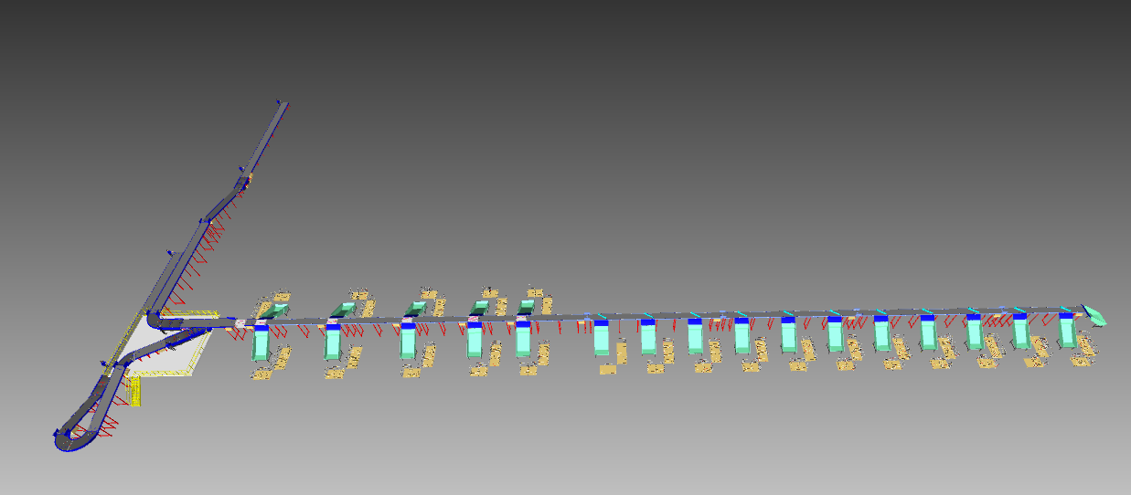
Layout View
1
6
5
5
5
4
4
3
2
1

Legend
1 – Loading Conveyor
2 – Induct lines
3 – SWEDI units (6 Nos)
4 – ARM Diverter (11 Nos)
5 – Collection Type chute
6 – Sort fail chute

Proposed System Capacity

System Capacity
Activity | Parcel per hour
SWEDI Diverter | 1500
ARM Diverter | 1500

System description

Loading conveyor
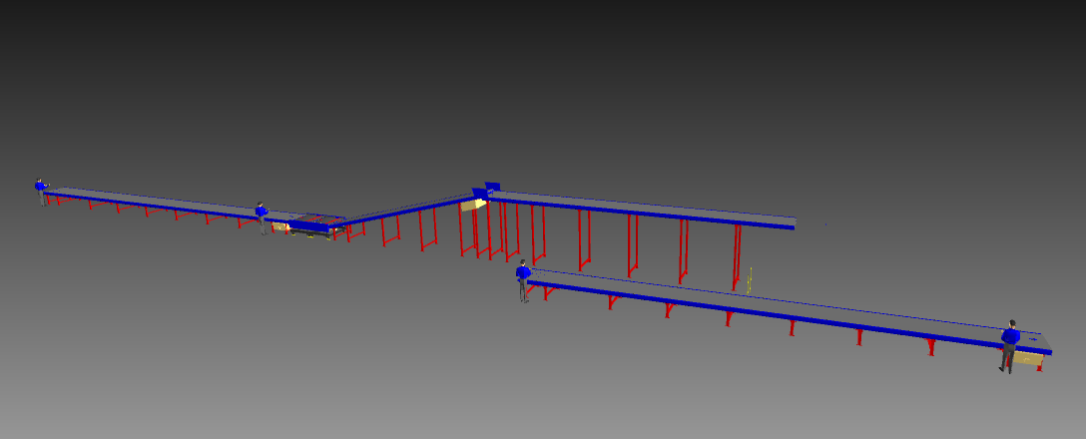
1
1

Legend
1 – Loading conveyors

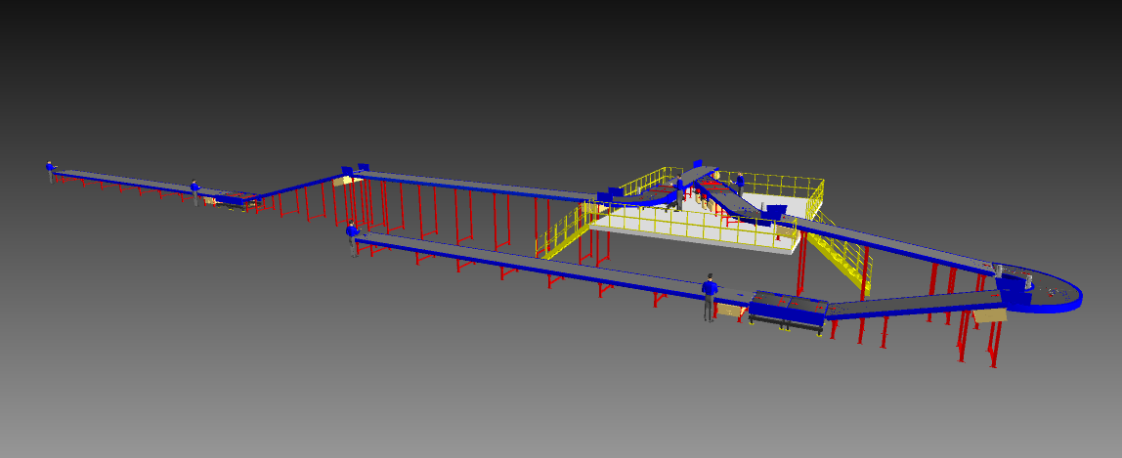
Manual Scanning
1
1
Legend
1 – Handheld manual scanning

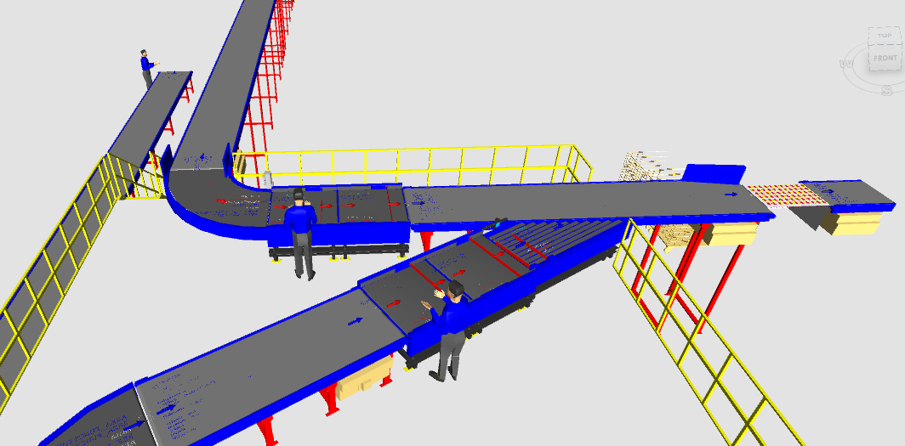
Parcel Induction

2
1
Legend
1 – Scanning conveyor
2 – Buffer conveyors
2 – Intelligent merge

3
1
2

Outbound Sorting
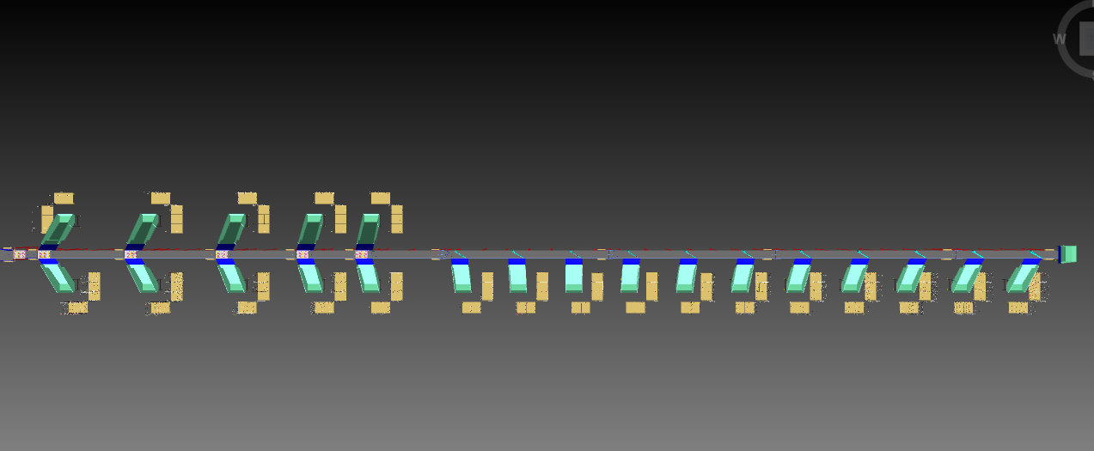
4
3
3
3
2
2
1
Legend
1 – SWEDI diverter
2 – ARM diverter
3 – Collection chute
4 – Sort fail chute

System Components

PVC Belt Conveyor
Falcon’s Belt Conveyors are modular & robust in design. MS profile is used to build conveyor frame.
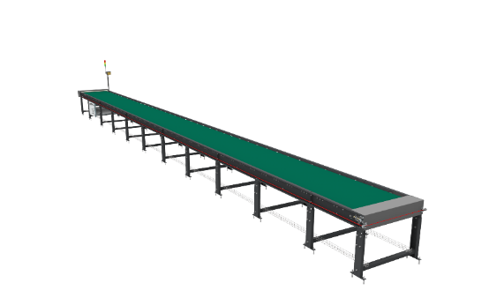
Some Salient Features of Falcon’s Belt conveyor:
- Low Noise
- Maximum uptime.
- Minimal maintenance
- High safety standards.
- Fastest ROI.

Specification | UOM | Remark
Manufacturer Name | Name | Falcon Autotech
Material of Roller | Type | MS Rollers with Zinc Plating
MOC of Belt | Type | PVC
Belt Thickness | mm | 3
Belt Finish | Type | Matt Finish
Belt width | mm | 1200
Belt Joint Type | Type | Vulcanized, Endless Belts
Belt Make/Model No. | Make | FORBO/DERCO
Chassis | mm | MS, 3mm Thick, Powder Coated-75 Microns
Idler Roller Pitch on running side (Top) | mm | 480
Idler Roller Pitch on return side (Bottom) | mm | 1200
Idler Roller Specs | Spec | Dia.50.8, shaft-12 mm, bearing-6301
End Rollers | Spec | Dia 81.2 x 2.85 Thick, 30mm Shaft Dia, & Bearing Size-UCFH206D1, MOC-EN9, Zinc Plated -25 microns
Drive Rollers | Spec | OUTER Dia 178 PIPE Dia 168x5 Thick, 40mm Shaft Dia, & Bearing Size-UCF208D1, MOC(SHAFT)-EN9, NEOPRENE RUBBER COATING
Tensioning Rollers | Spec | Dia 81.2 x 2.85 Thick, 25mm Shaft Dia, & Bearing Size-UCT205D1, MOC-MS, Zinc Plated -25 microns
Type of Drive | Type | Rubberized
Angle of wrap/Contact - Belt with Drive pulley | Deg | >180 deg
Motor Shaft | MOC | EN9 Shaft material,
Conveyor Under guarding | Spec | MOC-MS, 0.8 to 1mm thickness, Steel Stiffeners at every 600mm to avoid the sagging due to self-weight
Load capacity per unit length of Conveyor | kg/m | 50
Drive Power Rating | kW | Motor Rating depends on Length of the Conveyor
Type of Motor | Type | AC Geared Motor
Type of Drive System | Type | Direct Shaft Mounted Motor/ Flange Mounted
Type of Drive | Type | Chain drive/Torque Arm type
Gear Motor | make | Sew/Nord
Drive | make | Lenze/Siemens/Omron/Allen Bradly
Insulation Class | Type | Yes
Conveyor Speed | m/s | Variable speed to meet TPH requirements
Type of Mounts | Type | Fixed Heights Legs with Grouting Provisions

Plastic Modular Belt Conveyor
Falcon’s Belt Conveyors are modular & robust in design. MS profile is used to build conveyor frame.
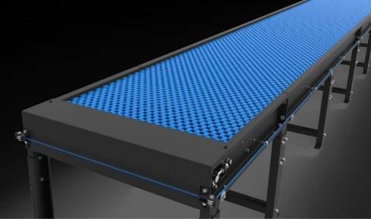
Some Salient Features of Falcon’s Modular Belt conveyor:
- Low Noise
- Maximum uptime.
- Minimal maintenance
- High safety standards.
- Fastest ROI.

Specification | UOM | Remark
Manufacturer Name | Name | Falcon Autotech
Plastic Modular Belt Material | Type | POM with PBT Pins, Pitch-25.4 mm, Pin Dia- 5mm
Plastic modular Belt Make/Model No. | Make | Movex/XP254 CR
Sprocket Size & No. of Sprockets on Drive End & Tail End | Type | 5/146.4 mm
Sprocket material | MOC | POM
Chassis | mm | MS, 3mm Thick, Powder Coated-75 Microns
Wear Strip Material | MOC | UHMW PE1000
Wear Strip Pitch | mm | 150 (Strip Width - 40mm)
Return Roller type | Type | DIA- 50 mm/20303
Return Roller Pitch | mm | 800
Driven Shaft | Type | MOC-EN9 Solid Shaft hardened to BHN 240, Size-60SQ MM, Zinc Plated -25 microns, Bearings-UCF-210D1
Duplex Sprocket | MOC | MS
Duplex Chain | MOC | MS
Drive Shaft | MOC | EN 24
Conveyor Under guarding | Type | GI SHEET (1MM THICK)
Type of Guides | Type | Steel guides at 50mm/400mm height basis the position of conveyor on both sides from Conveyor Belt Surface.

Swivel Wheel Sorting Unit - Falcon
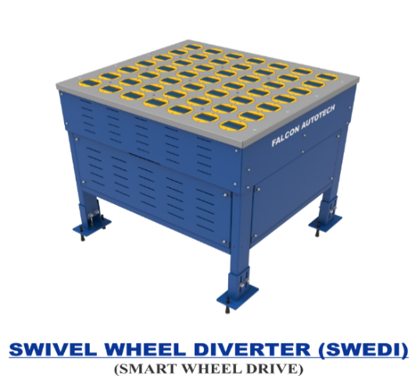
Falcon’s Swivel wheel divert is used in system for the smooth transfer of products.
Some Salient Features of Swivel Wheel Divert:
- Low Noise
- Maximum uptime.
- Electric based rotation of wheels.
- Minimal maintenance
- High safety standards.

Specification | UOM | Remark
Manufacturer Name | Name | Falcon Autotech
Type - Equipment | Type | Merge/Sorting
Type - Operation | Type | Sorting
Mechanism for Swivel | Type | Electric servo motor
Roller drive | kW | Powered smart wheel
Roller pitch (L x W) | Type | 110 x 120
No. of divert sections | Yes/No | 1 or 2
Type of Mounts | Type | Fixed Heights Legs with Grouting Provisions

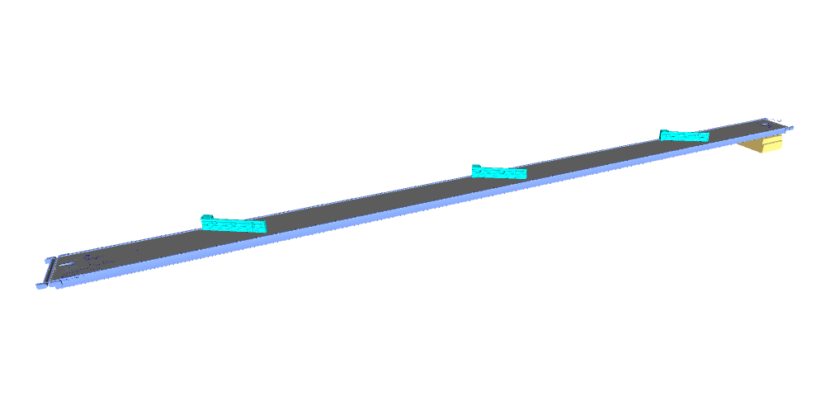
ARM Sorting Unit

Powered Belt Merges & ZTR Curves (Pic for ref.)
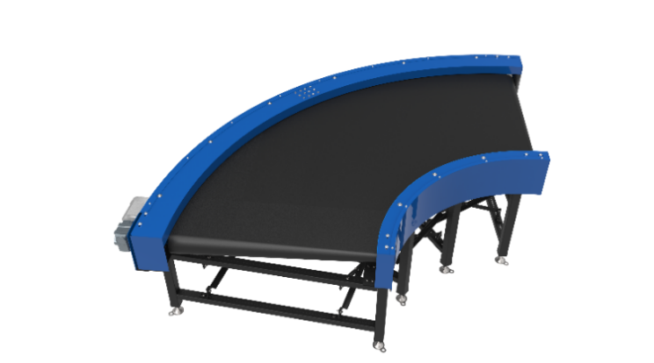
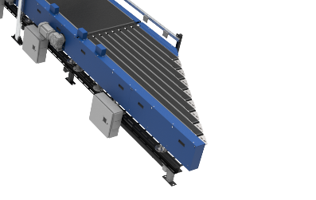

Handheld Barcode Scanners

Both induction lines area will be equipped with a Handheld wireless 2D Barcode scanner This scanner works as a backup for Auto scanner as well to ensure higher system redundancy.

Collection Type Chute
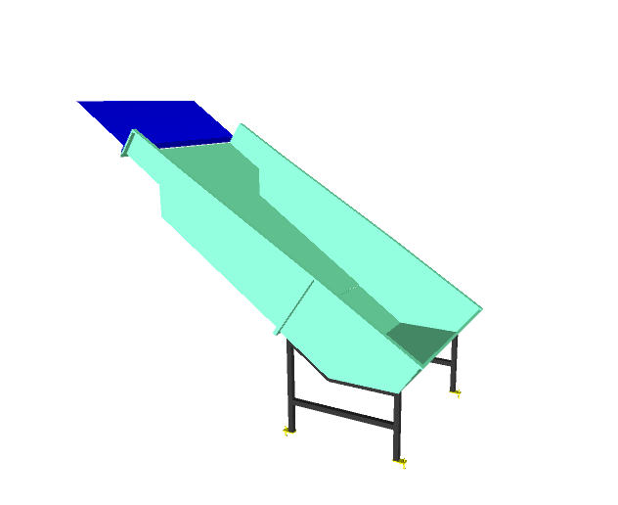

Operator’s Platform
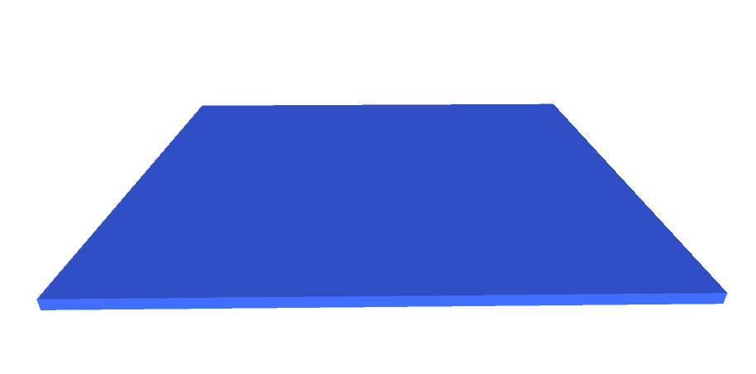

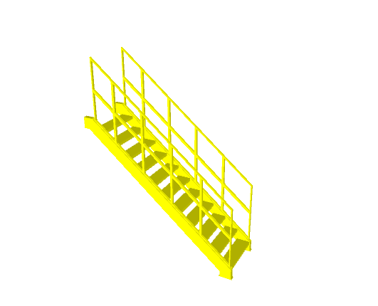
Stair case

Proposed System Technical Details/BOM

Mechanical Equipment
S.no. | Qty. | Description | Value
1 | 1 | Conveyors  13 X Powered belt conveyor ~ 118 m  01 X Modular conveyor~ 6.7 m  04 X Modular conveyor~ 64 m (Arm sorter)  02 X Scanning conveyor  03 X 90 deg Curves  01 X 60 deg Curves | Width  ~ 1210 mm
2 | 1 | Diverter  06 X SWEDI units  11 X ARM units | Included
3 | 1 | Destination/Chute  21 X Collection type chute  01 X Sort fail chute  Tower lamp (As per req.) | Included
4 | 1 | Steelwork  01 X Operator’s Platform ~ 86.9 sqm  02 X Staircase | Included
4 | 1 | Scanning Unit  02 X Handheld barcode scanner | Included
5 | 1 | Standard Flipkart Safety Equipment | Included

Electrical Equipment
Electricals
1 | 1 | Consists of  Main Control Panel  Network Switches  Field Cabling | Included

Control System
Components
2 | 1 | Controls, IT and Wiring  Software Package  Control Panels  Sorter Control  Electrical & Control Hardware  Switches  Drive panels  Operator Panels  Internal & Field Wiring | Included

Falcon’s WCS CONTROLIT
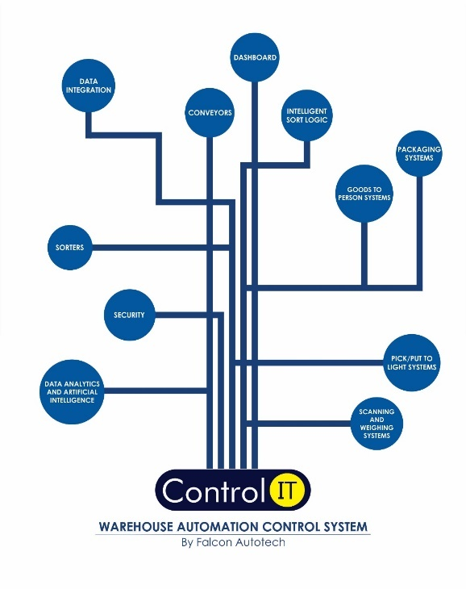
Key Values
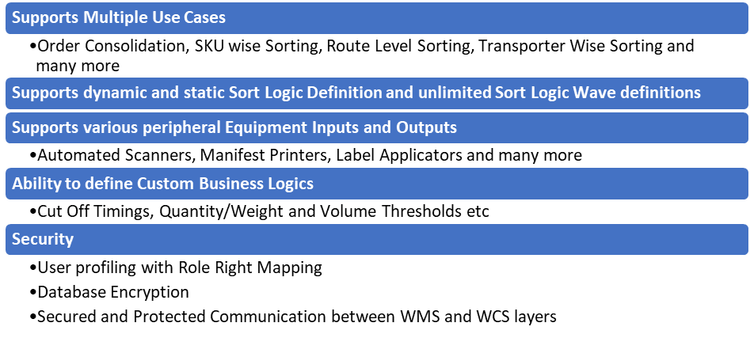Supported Protocols
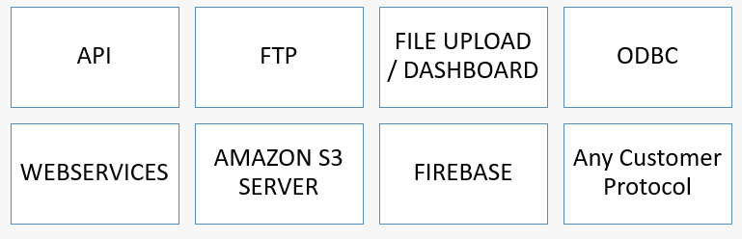

High Availability Server Specifications (In Flipkart’s Scope)
S. No | Configuration | Role | Qty | Purpose
1 | Dell PowerEdge T440 (Chassis with up to 8, 3.5" Hot Plug Hard Drives) Tower  Server Trusted Platform Module 1.2 Intel Xeon Silver 4110 2.1Ghz, 8C/16T, 9.6GT/s 2UPI, 11M Cache, Turbo, HT (85W) DDR4-2400 40 GB (2 x 16GB,8 GB) RDIMM 2666MT/s Dual Rank 2 x 1TB SATA 7.2K 3.5" 6Gbps Fully assembled (Hot Plug) Hard Drive PERC H330 Integrated RAID Controller DVD +/-RW, SATA, Internal Single Hot-Plug Redundant Power Supplies (1+0) 495W Dual-Port 1GbE On-Board LOM iDRAC9 Express 3Yrs Basic Warranty - NBD | Node 1 - Prod Server | 1 | Failover Cluster is configured on this system. If this node fails, then the VM shifts from this node to another and vice versa
2 | Dell PowerEdge T440 (Chassis with up to 8, 3.5" Hot Plug Hard Drives) Tower  Server Trusted Platform Module 1.2 Intel Xeon Silver 4110 2.1Ghz, 8C/16T, 9.6GT/s 2UPI, 11M Cache, Turbo, HT (85W) DDR4-2400 40 GB (2 x 16GB, 8 GB) RDIMM 2666MT/s Dual Rank 2 x 1TB SATA 7.2K 3.5" 6Gbps Fully assembled (Hot Plug) Hard Drive PERC H330 Integrated RAID Controller DVD +/-RW, SATA, Internal Single Hot-Plug Redundant Power Supplies (1+0) 495W Dual-Port 1GbE On-Board LOM iDRAC9 Express 3Yrs Basic Warranty - NBD | Node 2 - Prod Server | 1 | Failover Cluster is configured on this system. If this node fails, then the VM shifts from this node to another and vice versa
3 | Intel® Xeon® processor E3-1200 v5 product family, 16 GB RAM, 1 TB * 2HDD, RAID 1, iDRAC8 Enterprise (upgrade), 3 years Onsite warranty. | Domain Server | 1 | Hyper V will work with Domain System So that we required Domain Server Which will manage the nodes
4 | Synology storage with 4 TB HDD | Network Storage Box 1 | 1 | For Creation of Clustered Share Volume, VM will be created on this BOX
5 | Synology storage with 4 TB HDD | Network Storage Box 2 | 1 | Backup & Replication of CSV
6 | Power Backup | Power Backup | 3 | UPS for the Servers & Network Boxes
7 | Monitor - 19.5 inch | Monitor | 1 | Monitor
8 | KVM Switch | Switch | 1 | To switch over the display between servers
9 | Windows Server 2016 Standard R2 or Higher | Windows License | 3 | OS

Key Component Makes
Component | Make
PLC & RIO | Siemens
VFD | Siemens/Omron/Lenze/AB
Ethernet switch | Siemens/Phoenix Contact
SMPS | Omron/Selec/Meanwell
Slim relays | Phoenix contact
Terminals | Wago
Tower lamp + Hooter | Leuze
Switchgear | Schneider
Geared Motors | SEW
Volume Scanner | N/A
Cameras | N/A
Weighing Scale | N/A

Safety

Push Buttons

Push Button
Emergency Push Buttons will be provided at all the points of human interaction on the system as per Falcon Standard design parameters.

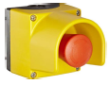

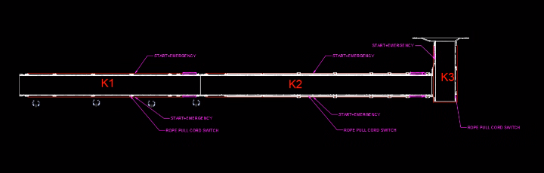

Program Management
For this program, proposed approach covers the following aspects:
- Creation and monitoring of the project plan.
- Communication with Flipkart
- Scheduling of the resource management.
- Management of the risks and opportunities.
- Management of the list of anomalies or reservations.

Commercial Terms

Price Sheet
S. No | Component | Set | Price (INR)
1 | SWEDI Diverters | 1 | ₹ 95,62,740
2 | ARM Diverters | 1 | ₹ 91,09,000
3 | Conveyors | 1 | ₹ 1,64,29,036
4 | Collection Type Chutes | 1 | ₹ 42,76,859
5 | Operators Platform | 1 | ₹ 13,29,436
6 | Software Packages | 1 | ₹ 6,00,000
7 | Toolkit | 1 | ₹ 79,800
8 | Installation & Commissioning | 1 | ₹ 20,39,344
9 | Packaging & forwarding | 1 | ₹ 8,15,737
10 | Project Management | 1 | ₹ 11,06,049
Total (INR) |  |  | ₹ 4,53,48,001

The Total Price is to be understood.
- Freight- Excluded
- GST will be charged extra @ 18%
- Including Packing and Forwarding
- Installation and Commissioning: Included
- Price is valid for 60 days from the date of proposal.
Our Price does not include taxes, and duties, import duties, charges, fees, taxes etc. charged by authorities outside India for deliveries and services. Same shall be borne & paid by client itself.
*Material Unloading & Laydown area is in customer scope

Payment Terms
The Supplier Quotation is based on the following payment schedule:
Stage 1: 40% Advance along with PO
Stage 2: 50% + Taxes Against dispatch of the material
Stage 3: 10% against Installation

Delivery timeline
16 – 18 weeks for dispatch of the material from date of PO, Advance & DAP
5 – 6 weeks for Installation

Warranty Period
Falcons offered System comes with a standard warranty of 1 year (Starts from the date of beneficiary use) and post completion of warranty, customer can opt for Extended warranty. Warranty covers the following support:
- 24 X 7 Telephonic, Email and Remote Service Support when required
- Regular Software updates and Bug Fixes.
- Supply of Mechanical and Electrical components in case of failure (excluding damages as mentioned in Exclusion Clause)
The warranty does not apply to replacement or repair of:
- Normal wear and tear.
- Consumables.
- Faulty articles continued:
  - Failure to comply with the manufacturer's recommendations (logistics documentation, Technical Information Note, retrofit document) and the rules of the trade.
  - Negligence or abnormal use of equipment.
  - Anomalies produced by an environment of use, storage or transport that does not comply with the specifications or recommendations of Falcon: packaging, temperature, hygrometry, sector, insulation, etc.
  - A defect due to a cause external to the supplies and services of Falcon.
- Equipment other than that supplied by Falcon.
- Items that can be repaired exclusively by Falcon that have been repaired or attempted repairs other than those carried out by Falcon.
- Items that fail due to normal wear and tear of one or more of its components or whose tamper-evident seals (varnish, strip, etc.) have been broken or whose serial numbers have been removed or modified.
- Items damaged during transport to Falcon due to the use of unsuitable packaging.

Exclusions
The scope of supply includes all parts which are defined in the Supplier’s quotation.

All other parts which are not defined in the Supplier’s quotation do not belong to the Supplier’s scope of supply and are excluded. The following parts are also excluded:

- Steel work is not specified.
- Server PC
- Roll cage trolley
- Construction Power
- Building infrastructure; building structure, doors, fire exits, levelling devices, building extinguisher and fire alarm system, building heating and lighting system.
- Electrical power supply and wiring to the main control cabinets
- UPS for Controls and Drives
- Electrical Power for Installation
- Network Cabling up to the Main Server Rack
- Intermediate wiring to parts which are to be supplied by the Purchaser/others
- Emergency/Uninterruptable power supply
- Fire-alarm and fire protection devices
- Traffic and route markings
- Laydown Area
- Ram protection devices
- Cat walks, bridges, maintenance aisles and platforms- If not specified
- Assembly tools like forklifts and hoisting machines
- All kind of network incl. Local Area Network (LAN/WLAN), exceeding the scope described in Scope of Supply
- Any Kind of Civil work
- Any adjustment of the Supplier’s scope of supply to local rules and regulations
- X-Ray machines
- Roller cages/ Pallets
- Simulation and 3D animation of the sorter system
- Interface with other equipment not specified in this offer.
- Provision of facilities for the control room (furniture, air conditioning, heating, etc.).
- The supply and installation of fencing around the different corridors.
- Any item specifically indicated as not forming part of the subject matter of the Seller's supply in the offer documentation.

